**ARE YOU ‘MANAGEMENT’ MATERIAL?** - Vaishali Jain, BVCOE

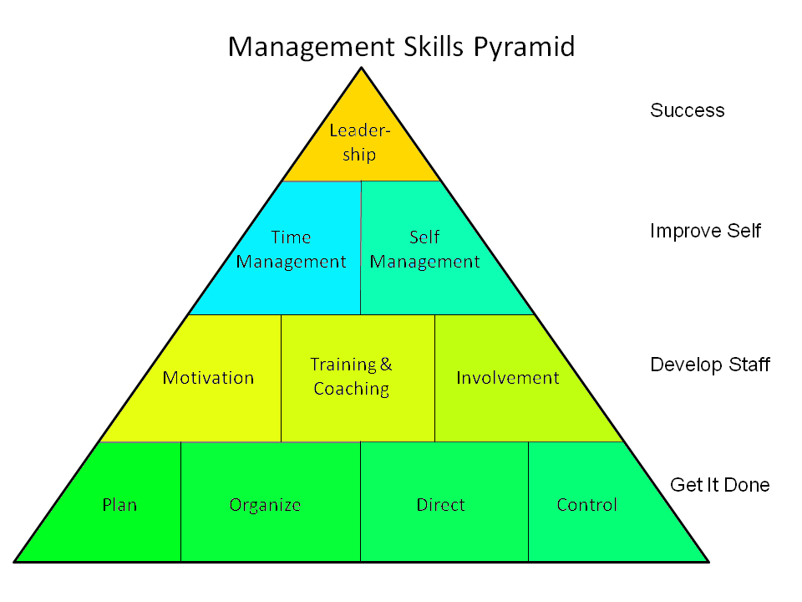

One night, I, on my bed trying to sleep but unable do so, had a thought, “What do I exactly want to do in my life?’ Studying in second year of an engineering college, after two years I will be viewed as an engineer. But do I really want to be one? For some time I struggled with this question. Then I made a list of what I want from my profession and it goes on like this: money, a fat pay package (who doesn’t want that?), power and status! Yes, I want all this. Now what should I do? And then I got my answer finally. It’s ‘MANAGEMENT’. The best option that suits my requirements.

Probably there are different criteria to check whether one can be a good manager or not. First and foremost, a person should have self confidence. Trust yourself and manage the work properly. Be positive and appreciate the work of others.

A good manager is not only good by his work but also by his nature. Self motivation, integrity, reliability, calmness, flexibility are some of personal characteristics of a good manager. One should be optimistic and possess an attitude which inspires other people you’re working with. It must help them getting things done.

Apart from personal characteristics one should be able to communicate effectively. To be an effective communicator, one should know how to speak in public, proclaiming ideas whether in an interview or while giving instructions to his/her fellow members. One should organize his/her presentations well. Be obstinate about his/her viewpoint, one should understand clearly what he/she wants to say. A manager with good communication skills should possess good listening skills too. One should listen carefully to one’s seniors, fellow members and juniors.

If you are dreaming of organizing or managing an enterprise then again you need to acquire management skills. As an entrepreneur your work is to solve problems, create new ideas and implement them. Combining these skills with your intelligence will not only amplify your leadership qualities but also maintain the dignity of your organization. As a leader you need to manage your team and coordinate between workers so as to avoid conflicts and misunderstandings. You are also required to regulate the performance of your whole team, as well as every individual. Monitor them wisely and bring the positive outcome and receive feedback. Thus, you will be able to represent yourself in public on the behalf of your team or organization, in an effective manner.

Management is required not solely in a professional environment but also in personal life. You should be able develop relations with other people and manage them well. Make peace with everyone and also try to solve misunderstandings and avoid conflicts as much as possible. You should be able to mediate well between your superiors and co-workers. Work as a team with others and make sure you will hold up till the end. Respect others, only then will you gain respect from others. Learn to appreciate others’ views and let them know about their mistakes, if any, in a polite manner. Value those who care for you and abide with them.

Thus a manager has to carry out different roles in everyday life. Organizing your team, resolving conflicts, generating new ideas and implementing them. The role of a manager is interesting as well as is a responsible task. So are you the ‘management’ material?

(Icon)

